Please e-mail this filled-in form to support@valx.eu

Procedural Conventions

- When a Service Case occurs, the customer has to notify the vehicle manufacturer first in accordance
with the guidelines stipulated by the vehicle manufacturer
- The requested information should be sent to VALX by e-mail within 48 hours after the failure was first discovered
- VALX will confirm registration of the Service Case within 2 working days after reception and process the Service Case within a reasonable amount of time
- The customer must offer VALX the opportunity to inspect the vehicle and/or the damaged parts
- The customer should only send defective parts for repair or replacement to one of the VALX repair centers when asked by VALX to do so
- The claim should, when possible, have pictures attached which clearly show the defect and a clear view of the identification plate of the landing leg
- Transportation charges are not covered

Contact Details

Service case applicant ☐ Vehicle manufacturer ☐ Vehicle owner ☐ Service dealer
Date Date
Company Text
Contact person Text
Country Text
Telephone number Text
Email address Text
Date of problem detection Date
Problem description Text
Text
Location vehicle Text
Contact person at vehicle Text
Telephone number contact Text
Vehicle manufacturer Text
Vehicle detail ☐ Central Axle Drawbar ☐ Drawbar ☐ Semi-trailer ☐ Dolly
Vehicle type ☐ Tilt ☐ Box ☐ Tipper ☐ Tanker ☐ Chassis ☐ Low bed ☐ Other
Vehicle registration date Date
Vehicle chassis number Text

VALX landing leg identification plate
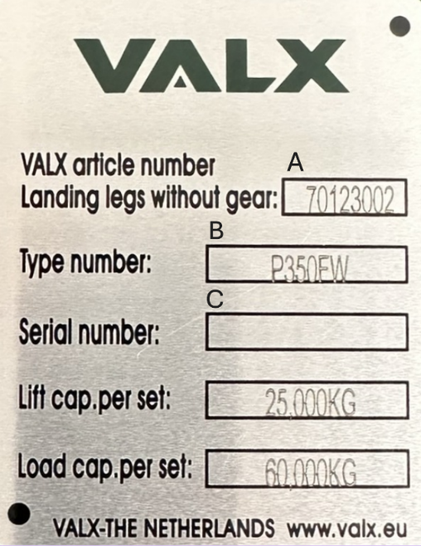

VALX landing leg identification plate:

A Valx article number
B Landing leg type number
C Serial number
Serial number leg with gear Text
Serial number leg without gear Text

Speciﬁcation of damaged product(s)
Valx product number Text
Supplier product number Text
Serial/Batch number Text
Valx invoice number Text
Customer order number Text

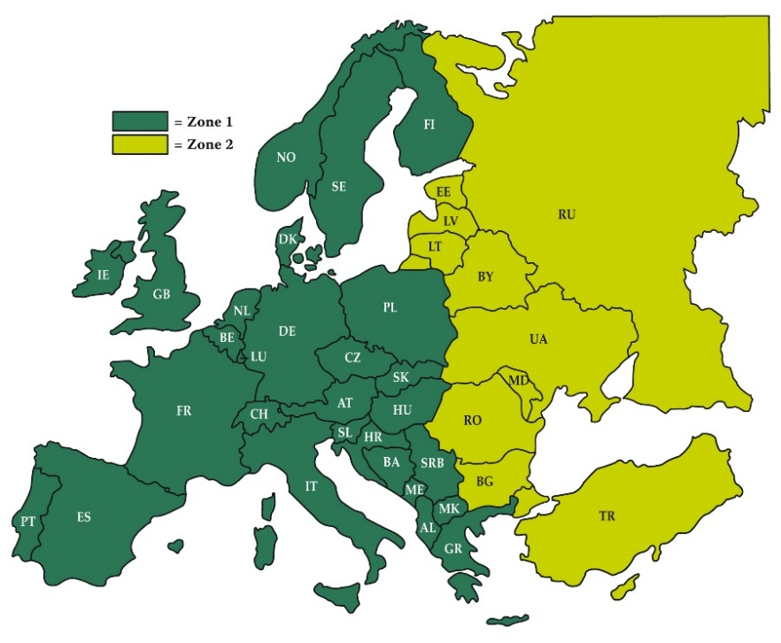
Geographical Zones

Off road usage ☐ YES ☐ NO
Usage in Zone ☐ 1 ☐ 2 ☐ 1&2

